

Project Progress Report for <sgEventHub>

Practice Module for Certificate in Designing Modern Software Systems

Team <03>

Members:

Liu Yikai

Li Jiayu

Zhang Kaidi

Fang Ziyue

Kyaw Lin

**CONTENTS**

**1. Introduction 3**

1.1. Project Name & Description 3

1.2. Project Methodology 3

1.3. Project Summary 3

**2. Project Progress Report 4**

2.1. Reporting period: from 16-Feb-2024 to 29-Feb-2024 4

2.2. Sprint Number: Spring 2 4

2.3. Sprint Objectives: 4

● finalize product details with UML graphs (done) 4

● finalize wireframes (partially done) 4

● finalize API plans (done) 4

● based on the finalized designs, finalise the infrastructure. 4

2.4. Sprint Accomplishment (Summary of work plan vs actual) 4

2.5. Sprint Burn Down Chart 5

2.6. Problems Encountered, Action Plan, Status 5

2.7. Sprint retrospective 6

2.7.1. What went well? 6

2.7.2. What could have been done better? 6

2.7.3. What will I try next? 6

# Introduction

## **Project Name & Description**

Project name is sgEventHub, which is a dynamic and user-friendly website that serves as a central hub for community events. This EventHub will provide residents with up-to-date information on local activities, workshops, community volunteerism, and social gatherings.

However, organizing events and managing the participants requires helping hands for the EventHub. Especially when the number of participants are huge, and events require customized options, it is not an easy task to host a successful event. Thus, the community encourages participants to volunteer as event owners/administrators for the events, to get rid of the cost wastage of getting a third party to manage events.

Our sgEventHub solution is separated for both community participants to enroll into their favorite events and volunteering event owners to manage these events, so as to form a sense of community encouraging participation.

## **Project Methodology**

In this project, we will be using scrum methodology to facilitate project activities such as

* Sprint Planning.
* Daily Scrum.
* Sprint Review.
* Sprint Retrospective.
* Sprint Backlog Refinement.

## **Project Summary**

This is a java-based web application which will serve community members a feature rich, user friendly platform. Project is designed to build with a Java backend and node.js framework as front-End. Since there are five members in the project development two developers are taking care of backend API generation. One developer for test cases, one for node.js interfaces, and the other for ci/cd pipeline, project coordination. All the project members are responsible for documenting their works along the project implementation.

Project Progress Report

## **Reporting period**: from 16-Feb-2024 to 29-Feb-2024

## **Sprint Number**: Sprint 2

## **Sprint Objectives**:

### finalize product details with UML graphs (done)

### finalize wireframes (partially done)

### finalize API plans (done)

### based on the finalized designs, finalise the infrastructure. (partially done)

## **Sprint Accomplishment** (Summary of work plan vs actual)

* + - 1. Planned at start of Sprint: 19 story points, 6 stories,

1. By the end of Sprint: 30 story points, 8 stories.
2. Accomplished: 14 story points
3. Carry forward: 16 story points.
4. We tried an offline Sprint planning as it’s hard to maintain members’ schedules post CNY holiday. The offline Sprint planning lasted for 2 days in which members are free to add in stories and discuss the story point estimate with the team.
5. We held a semi-group meet up to settle the overall design of the product. We worked on the UML use case diagram together and finished the use case description/DB entity design/wireframe offline.

## **Sprint Burn Down Chart**

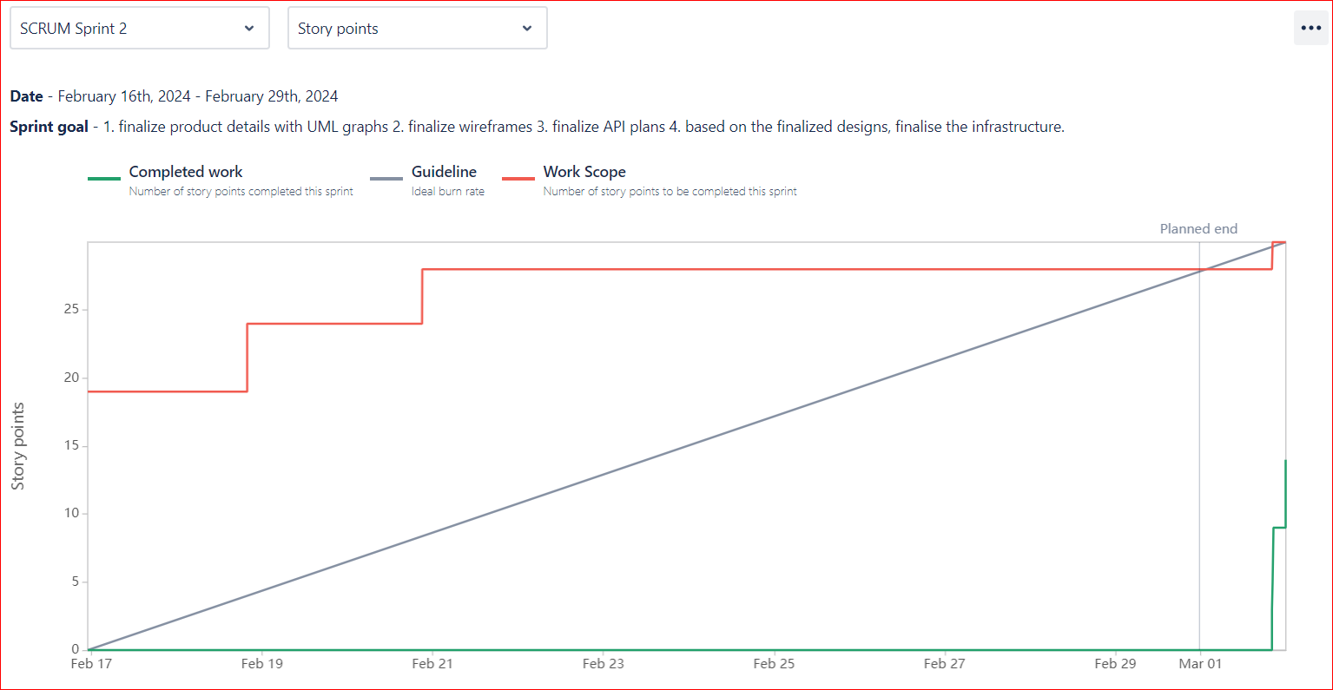

## **Problems Encountered, Action Plan, Status**

Team are having discrepancies in the overall design before the Sprint starts:

* Problem:
* The teammate that picked up the UML design story was unsure about the design details at first. The team then realized that the members didn’t come to an agreement on the product functionalities yet.
* Action Plan:
* We held a meeting that included several members and finalized a use case diagram. With this diagram as the base line, we then worked and discussed offline to finalize the other designs such as class diagram, use case descriptions, database entity diagrams, API plan and wireframes
* Status:

All team members now have a firmer understanding of our product. We are ready to proceed with more detailed design and development.

## **Sprint retrospective**

## What went well?

1. Finalized the product system design. The team has come to an agreement in most of the product details.
2. Active communication and collaboration within the team.
3. The team is getting more familiar with the agile Sprint operation

## What could have been done better?

1. We didn’t hold any regular meeting that included all team members due to the schedule difficulties. It will be improved in the following Sprints as all team members are back from holiday now.
2. Team members should have updated the Stories more frequently instead of only doing it when we are about to close the sprint.
3. Having difficulties in common understanding of the structure of the system as a whole at first and going on with uncertain design.

## What will I try next?

1. Progressively working on the sequence diagram and wireframes with the development
2. Link both Spring Boot BE with Reactjs FE.
3. Gradually design our CICD pipelines including the database servers and GitHub Actions flow.